**DAILY ONLINE ACTIVITIES SUMMARY**

|  |  |  |  |  |  |  |  |
| --- | --- | --- | --- | --- | --- | --- | --- |
| **Date:** | **28-05-2020** | | | | **Name:** | **Laxminarayan Miskin** | |
| **Sem & Sec** | **4TH SEM A** | | | | **USN:** | **4AL18CS044** | |
| **Online Test Summary** | | | | | | | |
| **Subject** | | **1. MICRO CONTROLLER AND EMBEDDED SYSTEMS**  **2. AADALITHA KANNADA** | | | | | |
| **Max. Marks** | | **1. 20**  **2. 50** | | **Score** | | **1. 03**  **2. 15** | |
| **Certification Course Summary** | | | | | | | |
| **Course** | **INTRODUCTION TO ETHICAL HACKING** | | | | | | |
| **Certificate Provider** | | | **GREAT LEARNING ACADEMY** | **Duration** | | | **6 HOURS** |
| **Coding Challenges** | | | | | | | |
| **Problem Statement:1:C program to find DIGITALROOT of a number.** | | | | | | | |
| **Status: EXECUTED** | | | | | | | |
| **Uploaded the report in Github** | | | | **YES** | | | |
| **If yes Repository name** | | | | **https://github.com/lax04/LockdownCoding** | | | |
| **Uploaded the report in slack** | | | | **YES** | | | |

**ONLINE TEST DETAILS:**



SNAPSHOTS:MES SNAPSHOT: AADALITHA KANNADA

1. The test was from 2nd module of MICRO CONTROLLER AND EMBEDDED SYSTEMS (18CS44).The time duration was 40 minutes from 12.00pm to 12.40pm.There were 20 questions of mcq type.score I received is 18/20.

2. The test was from all the modules of AADALITHA KANNADA(18KAK49) .The duration of the test was 50 minutes from 2.00pm to 2.50pm.50 questions of mcq type.score I received is 25/50.

**CERTIFICATION COURSE DETAILS:**

**Course:** Introduction to ethical hacking.

Today I learnt about :

1.Ethical Hacking in Web Applications-Demonstration.

2.Ethical Hacking on Mobile Platforms-Demonstration.

3.What is Ethical Hacking.

Completed with course and took the quiz assessment.

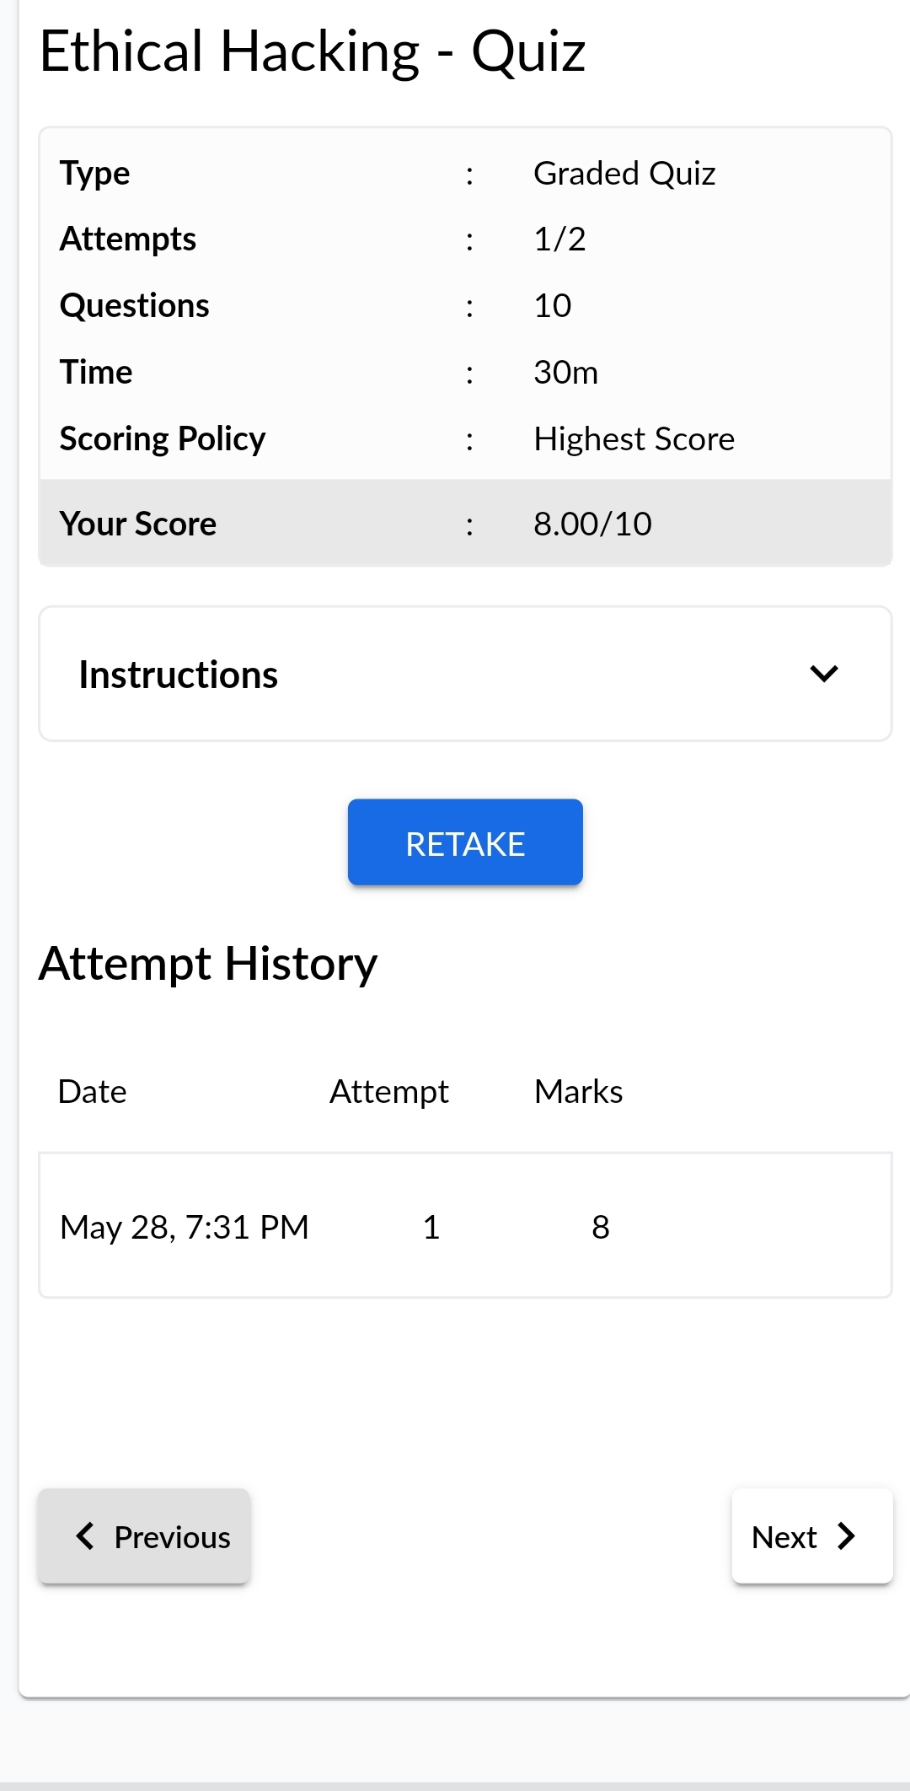

A

**CODING CHALLENGES:**

1.**C program to find DIGITALROOT of a number.**

Description:A digital root is the recursive sum of all the digits in a number. Given n, take the sum of the digits of n. If that value has more than one digit, continue reducing in this way until a single-digit number is produced. This is only applicable to the natural numbers.

digital_root(16)

=> 1 + 6

=> 7

digital_root(132189)

=> 1 + 3 + 2 + 1 + 8 + 9

=> 24 ...

=> 2 + 4

=> 6

